CURRICULUM VITAE

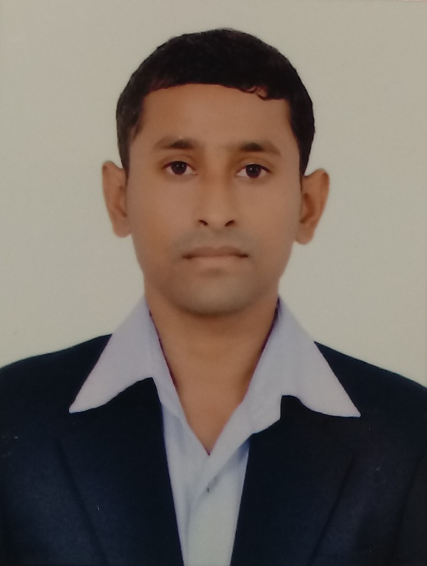
CHANDAN KUMAR
S/o.:- Mr. Surendra Kumar
At:- G-29, Gali No.-6B, Swatantra Nagar, Narela, Delhi 40.
Phone No.:- +91-7011180922,
+91-8899980446.
Email ID:- chandankraj17@gmail.com

Career Objective

Seeking for a challenging position as a Civil Engineer, where I can use my planning, designing and overseeing skills in construction and help grow the company to achieve its goal.

Academic Qualifications

- High School Passed from C.B.S.E. with 74.10% marks in 2010.
- Intermediate Passed (PCM) from C.B.S.E. with 59.00% marks in 2012.
- Passed B.Tech in Civil Engineering with 68.00% marks From International College of Engineering A.K.T.U. (UPTU) in 2012 to 2016.

Training & Certification

- Professional in Structural Design.
- 6 weeks industrial training in Daya Engineering Works Pvt. Ltd. Gaya, (Manufacturer of Pre-Stressed Cement Concrete Product) a unit of Patil Group, Hyderabad.
- Three day workshop in robotic programming and making (IIT Patna).
Project

- Highway network system.
Experience Detail

- Worked with Engineers & Architects Services at Shastri Nagar, Ghaziabad, Delhi NCR, as Architect Assistent from 1st June 2016 to 31st August 2017.
- Worked with C.V.S. Developer’s Pvt. Ltd. at Hindon Vihar, Ghaziabad, Delhi NCR, as Engineer from 18th Sep. 2017 to 18th May 2018.
- Presently working with S.S.Builders Pvt. Ltd ( A-Class Govt. Railway Contractor), Navyug Market Ghaziabad Delhi NCR, as Site Engineer from 19th May 2018 to till now.
Job Responsibilities

- Prepare Architectural & Interior Drawings as per design and specifications.
- Quantity Surveying.
- Prepare BBS (Bar Bending Schedule).
- Prepare Estimate & Billing.
- Site Supervision.

Technical Skill

Proficient in various Civil Engineering related software and standards:
- Design Software :- Autocadd (2D & 3D).
- Design & Analysis :- STAAD.Pro V8i.
- Professional Project Management :- Primavera V8.2.
- Quantity Surveying.
- Internet, M.S Office, Excell.
Hobbies

- Listening Music.
- Travelling.
- Swimming.
- Internet.
Personal Details

Father’s name : Mr. Surendra Kumar.
Mother’s Name : Mrs. Malti Kumari.
Address : KH No.-72/6, 7, Gali No-6B, Swatantra Nagar,
Narela, N.W.Delhi, Delhi 40.
Pin No.- 110040.
Date of Birth : 17th July 1995.
Gender : Male
Nationality : Indian
Language Known : English & Hindi.
Declaration

I hereby declare that the above written particulars are true to best of my knowledge & belief.
Date:
Place:
(CHANDAN KUMAR)

